**Aim:** Data Analysis and Inferencing using Pivot Table

**IDE:** Excel

### Theory:

A PivotTable organizes and then summarizes large amounts of data from any range that has labelled columns. Any number of column headings can act as category items. You can alternatively choose to create a PivotChart which will summaries the data in chart format rather than as a table. Details on creating a PivotChart are set out later in this section.

It is called a PivotTable because the headings can be rotated around the data to view or summaries it in different ways. You can filter the data to display just the details for areas of interest.

### The source data can be:

* An Excel worksheet database/list or any range that has labelled columns.
* A collection of ranges to be consolidated. The ranges must contain both labelled rows and columns.
* A database file created in an external application such as Access or dbase.

The data in a PivotTable cannot be changed as they are the summary of other data. The data itself can be changed and the PivotTable recalculated thereafter. However, formatting changes such as bold, number formats, etc. can be made directly to the PivotTable data.

# Creating a PivotTable

1. 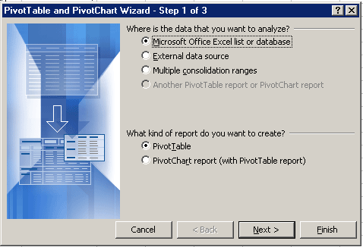Select a cell within your list.
2. From the *Data* menu select **PivotTable and PivotChart Report**.

### Choose Microsoft Excel list or database.

1. Choose **PivotTable** as the kind of report to be created.
2. Click the **Next** button to go to step 2 of the wizard.
3. This step verifies where your list data are. Provided the active cell was within your list when you launched the PivotTable wizard, the worksheet range will be your list.

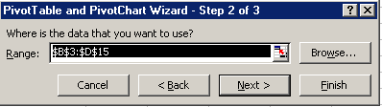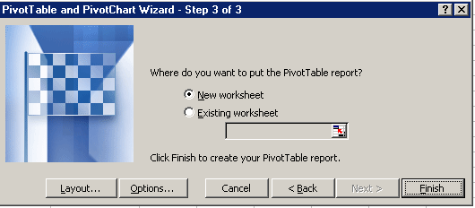

1. Click **Next**.

Step 3 is where you need to decide whether you want to construct the PivotTable on the worksheet or as part of the wizard process. Whenever possible, lay out the PivotTable or PivotChart directly on the worksheet so that you can easily view the data while you arrange the fields.

**Laying out a new PivotTable on the worksheet (preferred method)**

1. At Step 3 of the Wizard, select whether you want to put the PivotTable in a **new worksheet** or on the **existing worksheet**.
2. If you choose to put the PivotTable into the existing worksheet, you need to make sure you tell the wizard where to place it. The easiest way to do this is to click into an area in the existing spreadsheet. The cell reference will appear in the *Cell Reference* box.
3. Click on the **Finish** button.
4. The PivotTable layout, PivotTable toolbar and PivotTable Field List will be displayed.

PivotTable layout

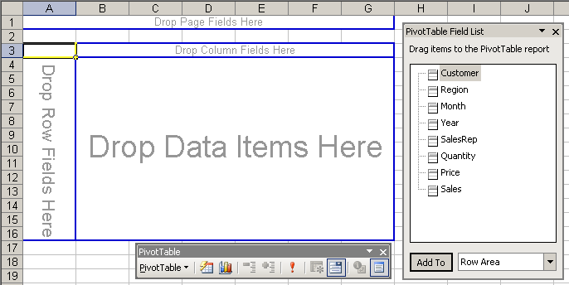

PivotTable Field List

PivotTable toolbar

***Arranging and filtering your data***

1. The PivotTable layout allows you to arrange and filter your data for analysis.
2. From the PivotTable Field List, drag the fields with the data you want to display in rows to the area on the PivotTable diagram labelled **Drop Row Fields Here**. You will have a filter button as part of the row heading to display just the data you want to see.
3. Drag the fields with the data you want to display in columns to the area labelled **Drop Column Fields Here**. You will also have a filter button as part of the column heading to display just the data you want to.
4. Drag the fields that contain the data you want to summaries to the area labelled **Drop Data Items Here**. Excel assumes **SUM** as the calculation method for numeric fields and **COUNT** for non-numeric fields. You can change the calculation method by double-clicking the field in the DATA area.
5. If you drag more than one data field, set the order by right-clicking a data field and then point to **Order** on the shortcut menu. Use the commands on the **Order** menu to move each field to the position you want.
6. Drag the fields that you want to use as page fields to the area labelled **Drop Page Fields Here**. Page fields allow you to display one data item at a time using a drop-down list.
7. To rearrange the fields at any time, simply drag them from one area to another.
8. To remove a field, drag it out of the PivotTable report. Fields that you remove remain available in the field list on the PivotTable toolbar.

**Laying out a PivotTable using the wizard**

1. At Step 3 of the wizard, click on the **Layout** button.
2. A list of column labels from your list will appear to the right of the dialog box.
3. Drag and drop the field buttons for the ROW, COLUMN and PAGE labels. Each row, column or page can have more than one label(s). This can be omitted for that dimension provided at least one dimension has one.
4. The PAGE area allows you to display one data item at a time using a drop-down list.
5. Drag column labels to the DATA area for the fields to summaries. Excel assumes **SUM** as the calculation method for numeric fields and **COUNT** for non-numeric fields. You can change the calculation method by double-clicking the field in the DATA area.
6. Format your summary field in the DATA area by double-clicking it and choosing the appropriate option. Click

**OK**.

1. Choose **Next** to move to the last step of the PivotTable wizard. Select a destination for your PivotTable. If you do not key in a destination cell, the result will be placed on a new Worksheet.
2. Click **Finish***.*
3. Whichever method you have used, the PivotTable Report will be displayed.

# Pivot Table toolbar

When you create or work with a PivotTable a PivotTable toolbar automatically displays.

Format report Chart wizard



Refresh data

# Managing PivotTables

When data is changed in the PivotTable source list, the PivotTable does not automatically recalculate.

## Refreshing a PivotTable

1. Select any cell in the PivotTable to be refreshed.
2. From the *Data* menu, select **Refresh Data** or click the refresh button  on the PivotTable toolbar.

## Modifying a PivotTable

A PivotTable can be modified by adding or deleting fields. Fields can be added and removed from the PivotTable in the worksheet or in *Layout* view.

### In the PivotTable report in the worksheet:

1. Select any cell in the PivotTable to be modified.
2. To add a field simply drag the required field(s) from the **PivotTable Field List** into position on the PivotTable report.
3. To remove a field, select the field name and drag it away from the PivotTable report.

### In Layout view:

1. Make sure the worksheet with the PivotTable is in view.
2. From the *Data* menu select **PivotTable** and **PivotChart Report**.
3. Click on the **Layout** option in the dialog box.
4. To add a field simply drag the required field(s) from the list of fields on the right into position on the diagram on the left of the screen.
5. To remove a field, select the field name and drag it away from the PivotTable diagram.

## Swapping PivotTable row and column headings

In the PivotTable drag the row heading to the column heading and vice versa.

## Formatting cells in the data area

1. To format the cells in a PivotTable you need to click in the area in the PivotTable to be formatted and then on the **PivotTable** button on the PivotTable toolbar and select **Field Settings**.
2. 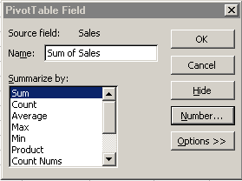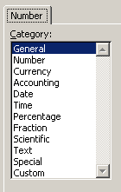Click on the **Number** button.
3. Select the Number format you want and
4. click **OK.**
5. Click **OK** again and your PivotTable will be re- formatted.

# PivotTable options

1. Clicking on the **PivotTable** button on the PivotTable toolbar, then selecting **Table Options** opens the PivotTable Options dialog box.
2. You can set PivotTable print options to set page breaks and repeat rows and columns labels for PivotTable reports that appear in an indented format.

# Grouping PivotTable items

Data can be summarized into higher level categories by grouping items within PivotTable fields. Depending on the data in the field there are three ways to group items:

* + Group selected items into specified categories.
  + Automatically group numeric items.
  + Automatically group dates and times.

## Grouping selected items

1. Select the items you wish to group. Select adjacent items by clicking and dragging, or non-adjacent items by selecting each item whilst holding down the **Ctrl** key.
2. From the *Data* menu, select **Group and Outline**, and then **Group**.

## Grouping numeric items into ranges

1. Select a single field item in the PivotTable.
2. From the *Data* menu, select **Group and Outline**, and then **Group.**
3. Excel displays a dialog box in which it automatically enters a start and end date. It also lists a number of intervals to group by.
4. 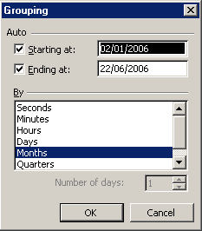Select an appropriate interval and click **OK**.

## Grouping a date or time in a range

1. Select a single field item in the PivotTable.
2. From the *Data* menu, select **Group and Outline**, and then **Group.**
3. Excel displays a dialog box in which it automatically enters a start and end date. It also lists a number of intervals to group by.
4. Select an appropriate interval and click **OK**.

# Formatting PivotTable reports

There are two types of formatting that can be used when displaying PivotTable reports – **indented** formats or **non-indented** formats. Indented formats are similar to traditional banded or formatted database reports which make a large or complex PivotTable report easier to read.

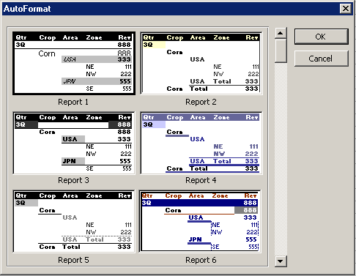The PivotTable wizard initially formats all PivotTable reports with a non-indented layout i.e., Table format. To change the layout:

1. Click the **Format report** button on the PivotTable toolbar.
2. For **indented formats** choose one of the formats labelled **Report 1** to **Report 10**.
3. Choosing one of these AutoFormats changes the report to indented format, changes the layout and applies character and cell formats.
4. All column fields in the PivotTable report are moved so that they become row fields. Column fields also move to the left of existing row fields so that the column fields become outer row fields.
5. Data fields move to the right of row fields.
6. If the name of the data field identifies the function for the field, the name changes so that the function name is omitted. For example, *Sum of Sales* becomes *Sales*.
7. For **non-indented** formats choose one of the formats labelled **Table 1** to **Table 10** or the **PivotTable Classic**

format.

Choosing one of these AutoFormats changes the names of data fields so that the function name is omitted.

### Pre-Lab Exercise:

* 1. What is the role of Excel in Data Analysis?
  2. What is pivoting in Excel?
  3. Why do we need to perform the pivoting in place of traditional analysis using excel?

### Tasks:

Perform the following tasks:

1. Average "total cost" and count of the product 1 under normal order category
2. Average "total cost" and count of the product 1 under short order category
3. Average "total cost" and count of the product 1 under large order category
4. Which month is having the highest count of orders placed?
5. Which year has the highest "average total cost"?
6. What is the ratio of the number of orders placed by male and female?
7. What is the ratio of the total cost of the orders placed by male and female?
8. How many orders are placed under each order category for the country "INDIA"
9. What is the total cost of order placed by the customer "Willis Brinks”?
10. Name the customer who has placed the order having the highest amount.

### Results:

Attach the screenshot of each task along with the output

**Task – 1 :-**

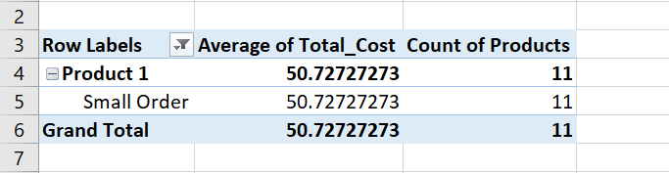

### Task – 2 :-

### 

### Task – 3 :-

### 

### Task – 4 :-

### 

### Task – 5 :-

### 

### Task – 6 :-

### 

### Task – 7 :-

### 

### Task – 8 :-

### 

### Task – 9

### 

### Task – 10

### 

### Observation and Result Analysis:

Write the final observation and process corresponding to each task

**1. _ _**

**_ _**

**_ _**

**2. _ _**

**_ _**

**_ _**

**3. _ _**

**_ _**

**_ _**

**4. _ _**

**_ _**

**_ _**

**5. _ _**

**_ _**

**_ _**

**6. _ _**

**_ _**

**_ _**

**7. _ _**

**_ _**

**_ _**

**8. _ _**

**_ _**

**_ _**

**9. _ _**

**_ _**

**_ _**

**10. _ _**

**_ _**

**_ _**

### Post Lab Exercise:

* 1. What considerations should be taken into account when choosing data for a pivot table?
  2. Differentiate between "Row Labels," "Column Labels," “Filters” and "Values" in a pivot table.
  3. Discuss the role of aggregation functions (e.g., sum, count, average) in a pivot table.
  4. Share insights derived from the analysis using the pivot table.